**Year 11 Human Biological Science**

**Test #3**

**Respiratory and Circulatory Systems**

Name: ____________________________________________ House/Tutor: _________

**PART A: Multiple Choice (20 marks)**

1. Blood carried in the pulmonary vein empties into which part of the heart?

a) right atrium

b) right ventricle

c) left atrium

d) left ventricle

2. What is the role of the papillary muscles?

a) They act as a portion of the skeleton of the heart, strengthening heart walls.

b) They keep the semilunar valves of the aorta and pulmonary trunk in position.

c) They keep the tricuspid and bicuspid valves from opening in the wrong direction.

d) They contract to move blood through the heart.

3. Capillaries connect arteries to veins to maintain a continuous blood supply. Capillaries

a) are one cell thick and allows nutrients to move into the cells.

b) are one cell thick that allows carbon dioxide to move from the plasma into muscle cells.

c) contain smooth muscle and can undergo vasoconstriction.

d) carry deoxygenated blood to the body tissues.

4. Oxygen is transported in the blood most efficiently by

a) being dissolved in the plasma.

b) chemical conversion to water.

c) combining with haemoglobin.

d) combining with carbon dioxide to form bicarbonate ions.

5. The volume of air that can be exhaled during forced breathing in addition to tidal volume is the

a) residual volume.

b) expiratory reserve volume.

c) vital capacity.

d) total lung capacity.

6. The diaphragm contracts during which process?

a) Exhalation

b) Inhalation

c) Respiration

d) Metabolism

7. Which of the following structures can most accurately be described as the respiratory surface of humans?

a) Capillaries

b) Bronchioles

c) Bronchi

d) Alveoli

8. Complete the sentence with the correct terms:

Blood from the legs returns through the _____1_____ and enters the ____2____ of the heart.

|  |  |  |
| --- | --- | --- |
|  | 1 | 2 |
| a) | Vena cava | Right atrium |
| b) | Vena cava | Left atrium |
| c) | Pulmonary vein | Right atrium |
| d) | Femoral vein | Left atrium |

9.

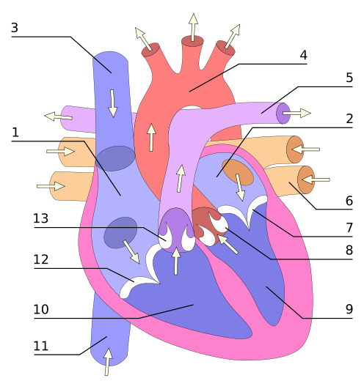

In the diagram above, the parts of the heart are correctly identified as:

a) 12 = atrio-ventricular valve 9 = left ventricle 4 = aorta

b) 5 = aorta 2 = right ventricle 4 = right atrium

c) 7 = atrio-ventricular valve 10 = left ventricle 1 = right atrium

d) 3 = vena cava 7 = semi-lunar valve 9 = right ventricle

10. The major driving force that moves blood back to the heart in the veins is

a) active transport.

b) passive transport.

c) the closing of one-way valves.

d) skeletal muscle contractions.

11. Which statement best describes how lymph fluid is returned to blood circulation?

a) Lymphatic ducts empty contents into major veins connected to the right atrium.

b) Lymphatic ducts empty contents into major veins connected to the left atrium.

c) Lymph passes through permeable lymphatic vessel walls and diffuses into capillaries.

d) Lymphatic vessels merge with venules in the major organs of the abdominal cavity.

12. Cardiac output can be reduced by

a) increasing heart rate.

b) decreasing stoke volume.

c) increasing the strength of ventricular contraction.

d) decreasing the concentration of oxygen in the blood.

The next TWO questions refer to the following diagram:

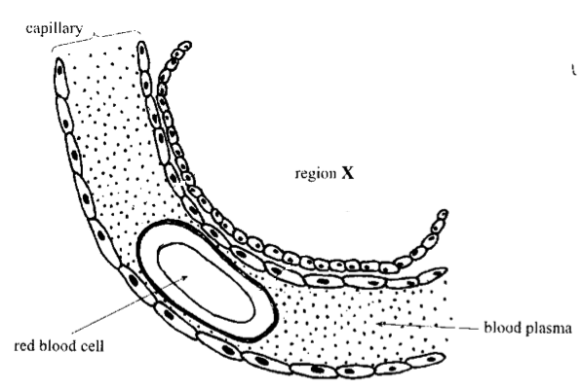

13. The region labelled X represents part of the

a) glomerulus.

b) alveolus.

c) villus.

d) cell.

14. The concentration of carbon dioxide gas in the capillary is

a) high and will move into region X.

b) low and will move into the blood plasma.

c) high and will move onto the red blood cell.

d) low and will move from the red blood cell to region X.

15. The ‘LUB’ part of the ‘LUB-DUPP’ sound the heart makes is caused by the

a) closing of the bicuspid and tricuspid valves.

b) closing of the semi-lunar valves.

c) sound of blood moving into the atria.

d) sound of blood moving from the ventricles.

16. During the last stage of the cardiac cycle, which of the following events is occurring?

a) Atria relax while the ventricles contract; atrioventricular valves are closed while the semilunar valves are open.

b) Atria contract while the ventricles relax; atrioventricular valves are open while the semilunar valves are closed.

c) Atria and ventricles are relaxed; atrioventricular valves are open while the semilunar valves are closed.

d) Blood moves from the right ventricle into the aorta while blood moves from the left ventricle to the pulmonary artery.

17. The highest carbon dioxide concentrations will be found in blood

a) leaving the muscles.

b) entering the muscles.

c) leaving the lungs.

d) entering the lungs.

18. Asthma

a) is a result of widening of the bronchioles.

b) can be treated with ventolin.

c) is always caused by allergies.

d) is a result of lack of mucous in the airways.

19. A person with a higher metabolic rate would

a) have a higher breathing rate.

b) have a lower cardiac resting rate.

c) eat less.

d) produce less energy.

20. Cartilage rings

a) form complete circles in the trachea.

b) prevent the oesophagus from collapsing.

c) maintain an open airway.

d) are found in the bronchioles.

**PART B: Short Answers (50 marks)**

1.

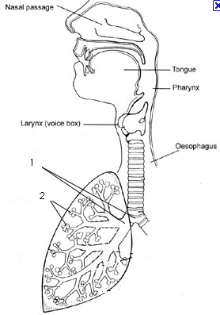

a) Name features 1 and 2 and explain how they are suited to the functions they perform. (4 marks)

_______________________________________________________________________________________

_______________________________________________________________________________________

_______________________________________________________________________________________

_______________________________________________________________________________________

b) Explain how carbon dioxide moves from the blood, into the lungs and out of the body. (2 marks)

_______________________________________________________________________________________

_______________________________________________________________________________________

_______________________________________________________________________________________

_______________________________________________________________________________________

_______________________________________________________________________________________

|  |  |  |
| --- | --- | --- |
|  | INSPIRED AIR  (Total volume) | EXPIRED AIR  (Total volume) |
| Oxygen | 21% | 17% |
| Carbon Dioxide | 0.04% | 4% |
| Nitrogen and inert gases | 78% | 78% |
| Water vapour | Varies | Saturated |
| Temperature | Atmospheric | Body (37o C) |

2. Expired air and inspired air differ in composition. The following table gives an approximate comparison.

a) Explain the differences or the lack of difference between the inspired and expired values shown in the table. (5 marks)

_______________________________________________________________________________________

_______________________________________________________________________________________

_______________________________________________________________________________________

_______________________________________________________________________________________

_______________________________________________________________________________________

_______________________________________________________________________________________

_______________________________________________________________________________________

b) Explain the difference between inspiratory reserve volume and expiratory reserve volume. Use a neat, labelled diagram to support your description. (3 marks)

_______________________________________________________________________________________

_______________________________________________________________________________________

_______________________________________________________________________________________

_______________________________________________________________________________________

_______________________________________________________________________________________

3. a) List the steps that must occur for a person to exhale. (4 marks)

_______________________________________________________________________________________

_______________________________________________________________________________________

_______________________________________________________________________________________

_______________________________________________________________________________________

_______________________________________________________________________________________

b)

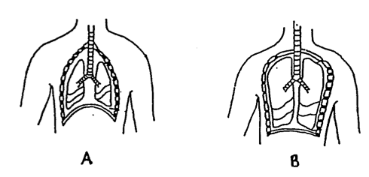

Which diagram indicates a person that is inhaling? Explain your reasoning. (3 marks)

_______________________________________________________________________________________

_______________________________________________________________________________________

_______________________________________________________________________________________

_______________________________________________________________________________________

4. The table below shows the main causes of death in Australia (2000).

|  |  |
| --- | --- |
| **Cause** | **%** |
| Cancer | 27.8 |
| Heart Disease | 20.7 |
| Stroke | 9.6 |
| Respiratory disease | 4.6 |
| Accidents | 4.0 |
| Diabetes | 2.3 |
| Influenza & Pneumonia | 2.3 |
| Other(s) | 28.6 |
| **Total (percentage)** | **100.0** |

a) List TWO factors that could contribute to heart disease being the second major cause of death in Australia.

(2 marks)

_______________________________________________________________________________________

_______________________________________________________________________________________

_______________________________________________________________________________________

b) There were 128 000 deaths in the year 2000. How many people died from heart disease **AND** respiratory disease? (2 marks)

_______________________________________________________________________________________

_______________________________________________________________________________________

_______________________________________________________________________________________

c) What is the difference between a heart attack and stroke? (2 marks)

_______________________________________________________________________________________

_______________________________________________________________________________________

_______________________________________________________________________________________

_______________________________________________________________________________________

d) The diagram below shows a capillary and the surrounding cells it supplies

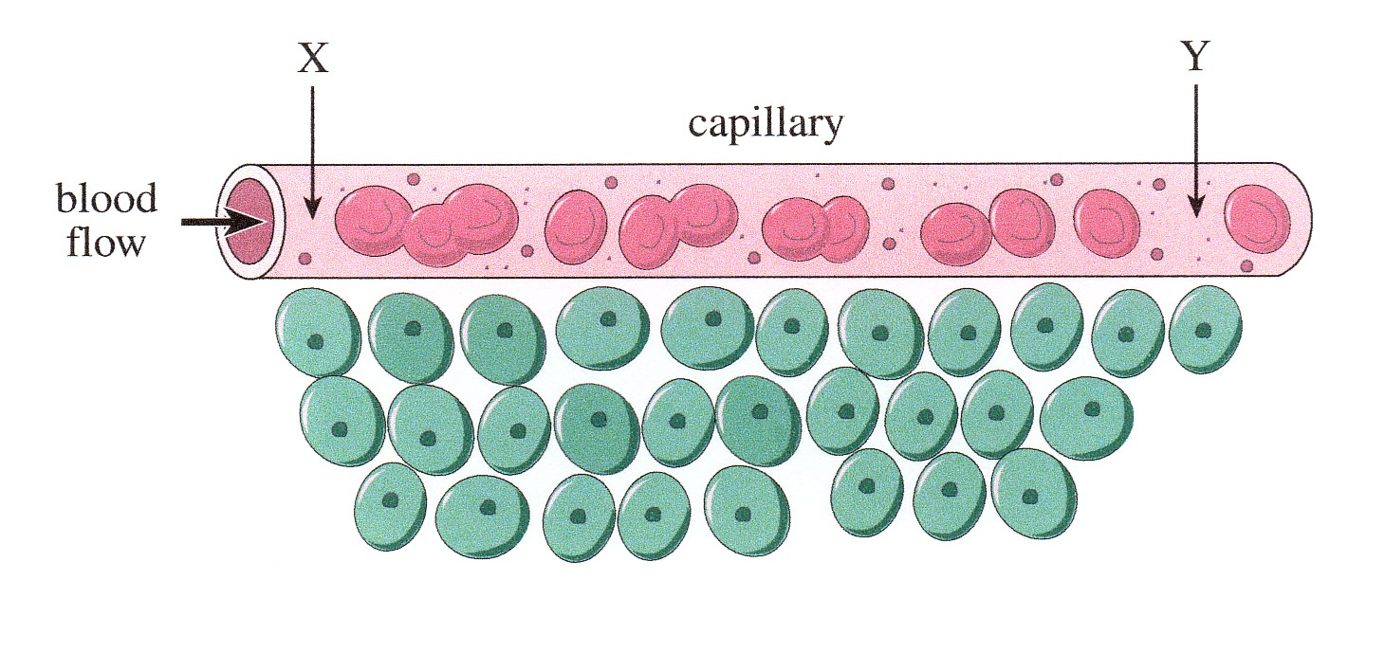

CIRCLE the CORRECT term in each of the following statements.

As blood flows through the capillary from Point X to Point Y: (6 marks)

i) the amount of glucose in the blood increases/decreases.

ii) the amount of oxygen in the blood increases/decreases.

iii) the amount of carbon dioxide in the blood increases/decreases.

iv) the amount of oxyhaemoglobin in the blood increases/decreases.

v) the amount of carbaminohaemoglobin in the blood increases/decreases.

vi) the pressure in the vessel increases/decreases.

5. Every time the heart beats, it causes fluctuations in the blood pressure of the body’s arteries. The graph below shows the effect of the cardiac cycle on blood pressure in the aorta of a healthy adult. Use the graph to answer the following questions.

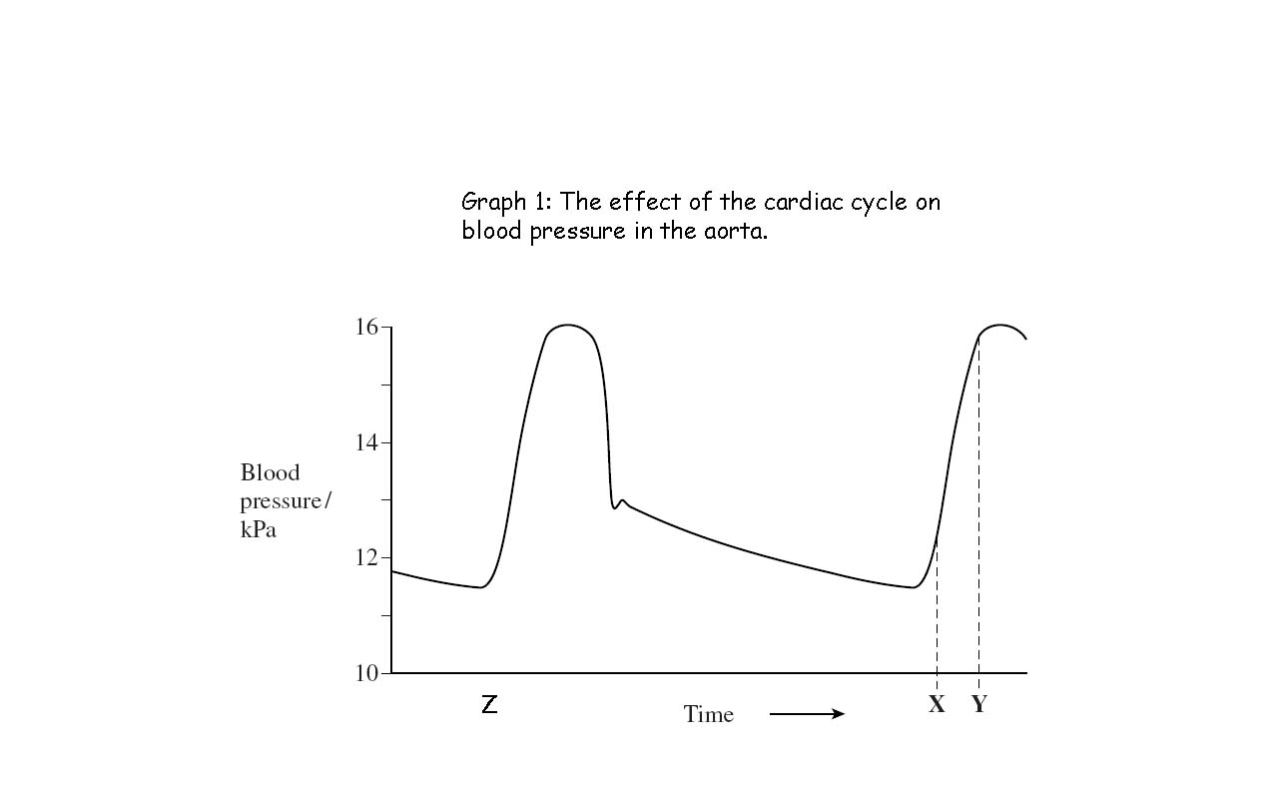

W

***The En***

a) State the diastolic blood pressure for this adult. (1 mark)

_______________________________________________________________________________________

b) A student chooses Point Z as the beginning of a cardiac cycle. Use the **Letter E** to indicate clearly where the **end** of this one cardiac cycle should occur. (1 mark)

c) Name the stage of the cardiac cycle that occurs between Point Z and Point W. (1 mark)

_______________________________________________________________________________________

d) Two stages of the cardiac cycle cause the changes in aortic blood pressure observed between Point W and Point X. Name these two stages of the cardiac cycle. (2 marks)

_______________________________________________________________________________________

_______________________________________________________________________________________

6. During a heart dissection, you notice that ‘one side’ of the heart is much thicker that the other side (see photo below). Your group members reckon this is because the thick side pumps more blood as the heart is a double pump.

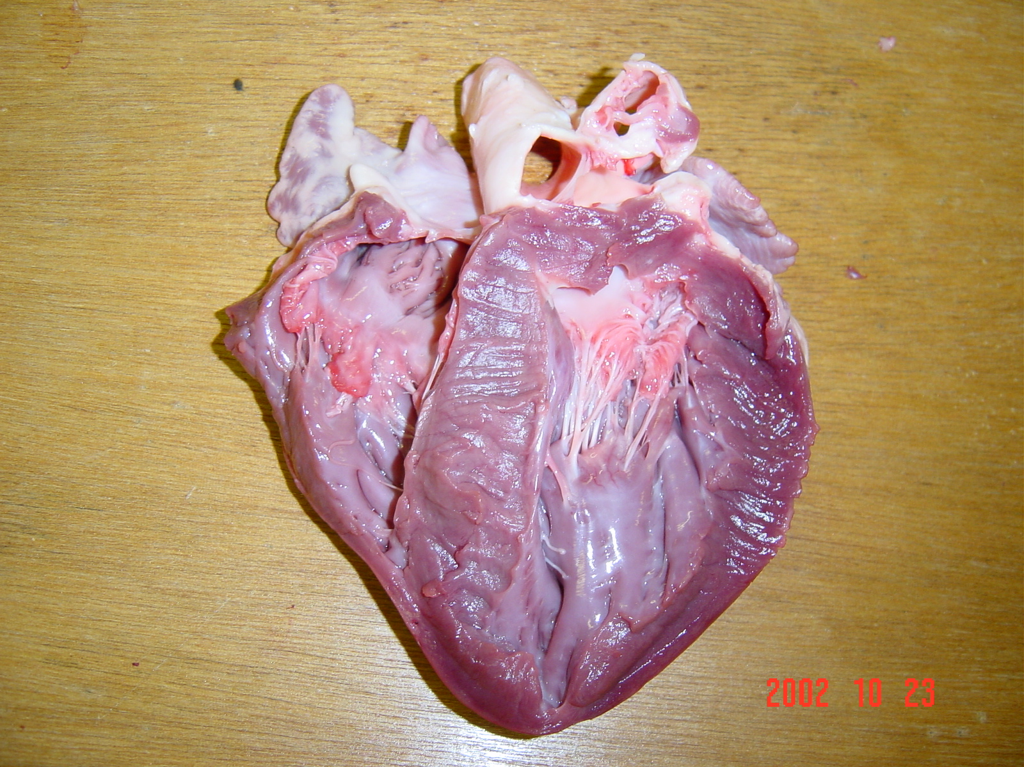

Thicker

Side.

a) What is the ‘thick part’ of the heart structure that is being examined? (1 mark)

_______________________________________________________________________________________

b) Are your fellow group members correct for stating that ‘*this side is thicker as it pumps more blood’*?

Explain. (2 marks)

_______________________________________________________________________________________

_______________________________________________________________________________________

_______________________________________________________________________________________

c) Why is the heart referred to as a double pump? (2 marks)

_______________________________________________________________________________________

_______________________________________________________________________________________

_______________________________________________________________________________________

_______________________________________________________________________________________

Near the end of the heart dissection, a group member accidentally cuts their finger. It began to bleed and

they applied a small pressure bandage. Over the next 30 minutes, their blood began to clot. This involved

the blood components: platelets and fibrinogen.

i) Where are platelets produced? (1 mark)

_______________________________________________________________________________________

ii) What is fibrinogen? (1 mark)

_______________________________________________________________________________________

_______________________________________________________________________________________

iii) What is the role of fibrinogen in blood clotting? (2 marks)

_______________________________________________________________________________________

_______________________________________________________________________________________

_______________________________________________________________________________________

_______________________________________________________________________________________

7. The graph below shows the pulse rate and the output of blood from the left side of the heart before, during and after a period of exercise.



a) What was the output of blood from the left side of the heart when exercise ended? (1 mark)

_______________________________________________________________________________________

b) What was the difference between the maximum and minimum pulse rates? (1 mark)

_______________________________________________________________________________________

c) What was the maximum cardiac output attained during the 22 minutes that the observations continued?

(1 mark)

_______________________________________________________________________________________

THE END